Social Exclusion Risk with Transportation Usage and Managing How to Stop Driving
Nahom Beyene, MSEng, Rory Cooper, PhD, Aaron Steinfeld, PhD
Department of Rehabilitation Science and Technology, University of Pittsburgh
5044 Forbes Tower, Pittsburgh, PA 15260
Human Engineering Research Laboratories, Department of Veterans Affairs, Pittsburgh, PA
Robotics Institute, Carnegie Mellon University
5000 Forbes Avenue, Pittsburgh, PA 15213

ABSTRACT
Access to transportation remains a major factor in the path to social inclusion. This study included volunteers living in Pittsburgh, Pennsylvania, who indicated that they have a disability or were age 55 or above, to complete a multi-part survey asking questions about transportation and travel in their community. The responses to these questions provided a quick and simple way to consider scenarios presenting varied levels of social exclusion risk. In addition, responses to questions about self-restrictions on driving and causes for driver cessation demonstrate the great need for driver rehabilitation services to assess driving capability and provide counseling on how to manage driver cessation.

KEYWORDS
Driving Status, Social Exclusion, Community Participation, Driver Cessation, Self-Restriction

BACKGROUND
When transportation options cannot accommodate the needs of people in a society, the impact can lead to social exclusion. The risk for social exclusion increases when people with disabilities (PWD) and older Americans are unable to use popular forms of transportation. While driving provides the most independent option for transportation, there are many challenges related to how people start and stop driving as well as how we evaluate driving capability (1). There is also a concern that cessation could be a phased process which incorporates multiple factors leading to a final end to driving (2).
In this study, the risk for social exclusion was evaluated by questionnaire response scenarios relating transportation usage to frequency of leaving the home. Additional responses relating to experienced driver cessation or use of self-restriction in driving habits augment the social exclusion risk evaluation. The results of this study present important considerations relating to the inner drive for community participation and personal perceptions of ability to drive safely.

METHODOLOGY
Participants were asked to complete the questionnaire in the form of a survey or interview. When preferred, the questionnaire was completed electronically or over the phone. The Institutional Review Board at the University of Pittsburgh approved this work under a broad study on factors contributing to driver cessation among people with disability and older adults.

Subject Recruitment:
Recruitment for study participants took place in Pittsburgh, Pennsylvania from December 2008 through July of 2009. The study reflected a combination of convenience sampling recruitment by using mailing lists, invited announcements, and word of mouth publicity. The study informational material was circulated through member lists of organizations or centers serving people with disabilities (PWD) and older adults. In addition, the Human Engineering Research Laboratories’ registry of wheelchair users provided a resource for recruitment. Inclusion criteria required that participants are age 18 and above, claim a disability or senior citizen status (55 or above), and complete the questionnaire in English.

Study Questionnaire:
The one time, multi-part questionnaire given to participants explored various concepts from driving cessation to community participation. The questionnaire built upon existing surveys used in prior studies (3). A subset of survey items asked questions regarding causes of driver cessation or techniques to maintain driver safety. The final section asked participants how often they leave their home and how frequently they use transportation. These questions provided the basis for investigating social exclusion with support from responses to questions on demographics and driving status.
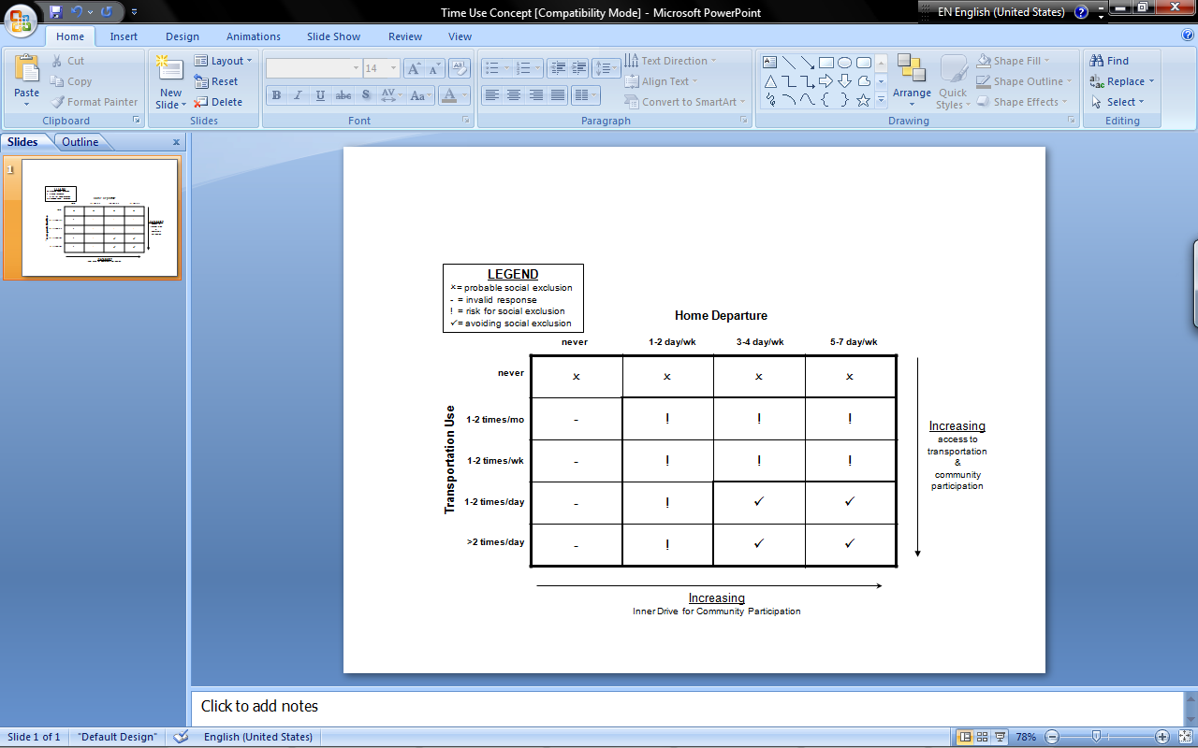Figure 1: Social exclusion scenarios due to discrepancy between home departure and transportation use.

Social Exclusion Risk Analysis:
For potential scenarios of social exclusion, a review of responses to frequency of departure from home and frequency of transportation use provided general experiences by the study participants. Figure 1 gives a general concept on how the juxtaposition of responses may reflect issues in access to transportation or social exclusion.
When frequency of transportation use is greater than departures from home, there is a scenario where use of transportation may be more intentional, efficient or consolidated for essential interactions in the community. However, this scenario may reflect social exclusion with a lack of routine access to transportation. Conversely, it is possible that overall access to transportation is lacking, while people possess an inner desire for community participation.
Furthermore, it is possible to view the combined factors to indicate varying levels of social exclusion scenarios. On the top and left borders, response of “never” indicates a strong likelihood for social exclusion due to incompatibility with available modes of transportation or inability to leave home. Conversely, the four cells on the bottom-right signify avoidance of social exclusion represented by high frequency of departure from home and transportation use. While responses in this area do not rule out hardships or inconvenience, social exclusion appears to be avoidable from the standpoint of access to transportation. The remaining eight cells present scenarios where compounding factors in the environment or transportation reliability can potentially lead to acute or permanent scenarios for social exclusion.

RESULTS
In total, 70 participants were informed about the study and 56 successfully completed the questionnaire. The participants were 59% female, and the average age of all study participants was 64.4 +/- 16.9 years (N=51, 5 subjects did not report age) with ages ranging from 22 to 88. The majority of participants were age 40 and above with a peak distribution in the 70s. Responses were reported with respect to driving status (continue to drive, N=28; ceased driving, N=14; and no driving experience, N=14) in order to identify relationships with social exclusion risk.
 |  | Home Departure
Driving Status | Transportation Use | Never | 1-2 day/wk | 3-4 day/wk | 5-7 day/wk
Never Drive  N=14 | Never
Never Drive  N=14 | 1-2 a month |  | 7.1%
Never Drive  N=14 | 1-2 a week |  | 7.1% | 14.3% | 21.4%
Never Drive  N=14 | 1-2 a day |  |  |  | 14.3%
Never Drive  N=14 | >2 times per day |  |  |  | 35.7%
Ceased Drive  N=14 | Never
Ceased Drive  N=14 | 1-2 a month |  | 7.1%
Ceased Drive  N=14 | 1-2 a week |  | 28.6% | 21.4% | 7.1%
Ceased Drive  N=14 | 1-2 a day |  |  |  | 21.4%
Ceased Drive  N=14 | >2 times per day |  |  |  | 14.3%
Still Drive  N=27 | Never |  |  | 3.7% | 3.7%
Still Drive  N=27 | 1-2 a month |  |  | 3.7% | 7.4%
Still Drive  N=27 | 1-2 a week |  | 3.7% | 14.8% | 22.2%
Still Drive  N=27 | 1-2 a day |  |  | 3.7% | 14.8%
Still Drive  N=27 | >2 times per day |  |  |  | 22.2%
Table 1: Social exclusion risk scenarios reported by study participants in all groups.

Travel Patterns and Social Exclusion
Using the conceptual approach for social exclusion risk analysis, actual responses are shown here in Table 1. The table compares across driving status groups, and activity patterns are discernable by summing group responses either horizontally or vertically. Only one participant was excluded for omitting a response to frequency of transportation use.
Responses occurred primarily along the diagonals or above in the subtables, where home departure begins to be more frequent than transportation use. The only responses reflecting probable social exclusion came from a minority of participants in the still driving group and reflect how valuable driving status is despite little to no use of transportation. The groups with nearly half of responses at risk for social exclusion included participants who still drive or ceased driving. Complementing these responses, the participants who appeared to avoid social exclusion best belonged to the group with no driving experience.
Viewing transportation use (summing percentages horizontally), the groups showed peaks in transportation use 1-2 a week and >2 times per day except for the ceased driving group. Home departure trends from vertical subtable summations reflected less frequent home departure among the ceased driving group as well. These activity patterns show that the ceased driving group had the largest risk groups bordering the area of probable social exclusion depending upon their inner desire for travel.
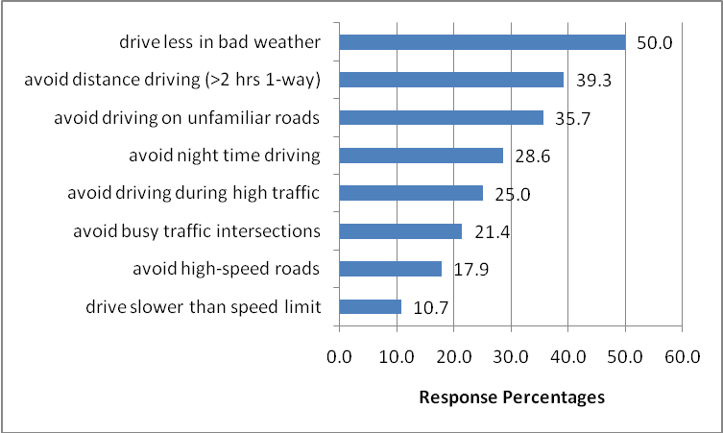Figure 2: Response frequencies for methods to maintain driver safety via self-restrictions (N=28).

Experiencing Driver Cessation
From the group of participants who ceased driving, ten out of 14 selected a reason for stopping, but none credited cessation due to family members or relatives taking away the keys. The responses attributed the decision to be personal or related to vehicle ownership, and a few claimed problems with license renewal. Overall, half claimed a perceived or diagnosed drop in capability and concern for safety or comfort with driving skills. These responses show strong personal control of the decision to stop driving, and the responsibility of determining when a drop in capability turns into a safety risk for driving.

Maintaining Driver Safety
As licensed drivers, participant responses revealed additional self-restrictions associated with driver capability and safe driving. Figure 2 presents the percentage of reported self-restriction techniques to maintain safe driving habits among the study participants who still drive.
The responses show that popular self-restrictions were to drive less in bad weather (50.0%), avoid distance driving (39.3%) and avoid driving on unfamiliar roads (35.7%). The restrictions mainly related to avoidance of issues addressable with trip planning more so than in-vehicle monitoring of driving performance. Further questioning provided more details about driving experience. Only three participants claimed to drive before onset of a disability although the responses were provided by only half of the group. Plus, one participant claimed to be uncomfortable driving without another person in the car. These results promote the great need for driver rehabilitation services, whether for driver training or evaluation of driving capabilities.

DISCUSSION
The average age of participants from the ceased driving group being 68.5 (N=12) shows a noticeable difference compared to the no driving group 58.9 (N=14). This age difference may incorporate inherent differences regarding desire for community participation and general expected capabilities, for driving or otherwise. Responses from an older group of participants with no driving experience would allow a stronger comparison for social exclusion risk by driving status. With 50% of participants still driving, the most popular self-restriction found in a national survey was also to drive less in bad weather, but the percentage found in the current study was lower as compared to over 66% among PWD. Considering half of the participants did not claim any disability and 80% were age 55 or above, it is likely that self-restriction decisions are influenced by age (4). Overall, these responses have shown increased risk of exclusion among people who have ceased driving. Given the older age of this group and dynamics of shifting self-restriction needs, there is increased complexity in advising how to apply self-restriction strategies and appropriate timing of cessation by personal judgment alone. There should be consideration of whether or not availability of current technology factors more into what people are doing for themselves beyond what is actually a part of the concern for driving capability.
Limitations to the study included skewed subject recruitment towards older adults over PWD and the overall questionnaire length produced a few complaints. While recruitment targeted many organizations serving the disability community at large and older adults, the participants reflected a limited number of experiences with sensory disabilities or mental health needs. This limitation prevented the possibility of reviewing responses in relation to varying types of disability.
From self-report of home departure and transportation use, frequency patterns can reveal where discrepancies occur. In the balance of access to transportation and efficiency in transportation use, one question is to what degree each person has the inner drive to participate in the community when transportation is required. At the same time, questions related to goal setting are necessary to identify where and how often a person desires to travel to routine destinations. When activity patterns do not synchronize with desired travel habits, then it is possible to predict that social exclusion is occurring as a limitation involving access to transportation, availability of finances, provision of assistive technology, presence of environmental barriers, pressure of societal values, or policy regulations.

CONCLUSION
In life, there are many occasions where multiple trips are required for a meeting, purchase, or exchange. As an example, a trip to the post office may be repeated because of excessive wait times. Similarly, transportation options can become unavailable. Bus riders suffer in mass when a breakdown delays scheduled stops, and car drivers sit at home fuming when severe weather makes road conditions unmanageable. The risk of social exclusion is thus greater for individuals who have single excursions from the home or use transportation on the weekly or monthly basis. When any conflict aligns with the day of community travel, participation in society is postponed and the experience of social exclusion remains until routine conditions resume.
This study showed a 75% report of driving experience with 50% still driving. It has been reported that 86% of adults age 50 and above rely on driving for transportation (5). With an expected increase of the senior citizen population, driver rehabilitation services need to be equipped for the increased demand of their services as well as the tools to empower their clients in making safer decisions about driving, without sacrificing community participation.

REFERENCES
- Freund, B. and D. Petrakos, Continued driving and time to transition to nondriver status through error-specific driving restrictions. Gerontol Geriatr Educ, 2008. 29(4): p. 326-35.
- Dellinger, A.M., et al., Driving cessation: what older former drivers tell us. J Am Geriatr Soc, 2001. 49(4): p. 431-5.
- Beyene, N., Steinfeld, A., and Cooper, R. Driving Status and the Inner Drive for Community Mobility and Participation: A Survey of People with Disabilities and Senior Citizens from Support Groups in New Delhi, India, 2009. RESNA Student Scientific Paper Platform Presentation, New Orleans, LA, June 27, 2009.
- United States. Bureau of Transportation Statistics., Freedom to travel. 2003, Bureau of Transportation Statistics, U.S. Dept. of Transportation: Washington, DC.
- United States. National Highway Traffic Safety Administration. and American Medical Association., Physician's guide to assessing and counseling older drivers. 2003, U.S. Dept. of Transportation American Medical Association: Washington, D.C. Chicago, Ill. p. 1 CD-ROM

ACKNOWLEDGEMENTS
This material is based upon work supported by the National Science Foundation under Grant No. EEC-0540865. The Survey Research Program (SRP) within the University Center for Social and Urban Research (UCSUR) at the University of Pittsburgh provided survey technical support and production.

First Author
Nahom M. Beyene
Human Engineering Research Laboratories
Department of Veterans Affairs, 151R-1
7180 Highland Drive
Pittsburgh, PA, 15206
412-954-5304

